FarmFury: Rampage — Game Design Document
Oct 8, 2026 · @Marius Bonthuys

1. Overview
FarmFury: Rampage is a portrait mobile lane shooter. A herd of FarmFury animals holds a farm track against marching robots, grows through maths gates, and defends a farm that the player rebuilds between runs. It takes the proven loop of Last Z: Survival Shooter and swaps zombies and soldiers for robots and farm animals, with mechanics that only make sense on a farm.
Elevator pitch: Agri-tech giant HARVEX has sent its robot army to bulldoze Fury Farm. Cluck, Bessie, Horace and Ducky fight back with eggs, milk, horseshoes and water, multiplying the herd through gates and turning scrap into a rebuilt farm.
Item | Decision
Genre | Hybrid-casual lane shooter ("gate runner") with a light base-building meta
Platform | iOS and Android, portrait, phone-first; WebGL build for playtests and ads
Engine | Unity 6 LTS, URP 2D/2.5D, built with Claude Code as the main coding partner
Session | 60 to 120 seconds per run; 5 to 10 minute play sessions
Audience | 9+ and casual adults; FarmFury's existing family-friendly tone, cartoon violence only (robots go "sproing", nothing bleeds)
Business model | Free to play: rewarded ads, light IAP, battle pass in a later phase

Design pillars
- Read it in one second. Every gate, robot and power-up is understandable at a glance on a 6-inch screen. If a playtester has to stop and read, the design is wrong.
- Same power, different feel. The four heroes deal the same damage per second. Choosing one is about play style and fun, never about a meta-best pick.
- The farm fights back. The farm itself is part of the arsenal: crops, mud, weather and barn upgrades change runs. This is the main thing that separates Rampage from soldier-and-zombie clones.
- Honest ads. Store and ad creatives show the game as it actually plays. Last Z and Last War grew on ad-only minigames; Rampage makes the ad loop the real game.

2. Reference analysis: Last Z: Survival Shooter
Last Z succeeds by putting a fast vertical auto-shooter on top of a slow base-builder: the shooter hooks players in minute one, and the base keeps them for months. Rampage copies that two-layer structure and its stage objects, but keeps the meta lighter and the tone family-friendly. Last Z: Survival Shooter is published by Omnilojo Pte Ltd, is rated 4.8 from about 102K ratings on the App Store, and is listed as a 16+ strategy game.

How Last Z is built
Layer | What Last Z does | Source
Shooter stage | Vertical scrolling arena; the hero squad moves up the screen, auto-fires, and dodges while zombie waves ramp up | BlueStacks
Stage objects | Breakable crates and barrels give extra soldiers, weapon upgrades and temporary buffs; XP crates level heroes | LDShop guide
Gates | Blue gates boost fire rate or squad size; red gates debuff the team; some gates fully charge hero skills | LDShop guide, Joytify guide
Hazards | Indestructible spikes, rotating saws, rolling wheels and fire traps that kill troops | LDShop guide
Heroes | Defender, DPS and Support roles; factions give static bonuses; tier lists (S to C) drive gacha spending | LDShop guide, Joytify guide
Base | Headquarters level caps buildings, troops and research; resources are food, wood and power; a pub runs recruitment | LDShop guide
Social | Alliances, world map, PvP, seasons (desert, tundra, jungle) | Lootbar review
Money | Resource packs from $0.99 to $99.99; reviewers call out pay-to-win and long timers after the early game | App Store, Lootbar review

What Rampage takes, and what it changes
Last Z element | Rampage version | Why
Soldier squad that grows | The Herd: copies of the chosen animal hero | Same squad-growth thrill, on-brand
Blue and red gates | Gates with maths (+, −, ×, ÷) and buffs; shoot a gate to improve it | Proven decision moment, more readable
Crates and barrels | Hay bales, feed sacks, milk churns, egg crates | Same "shoot it, get stuff" reward, farm flavour
Spikes and saws | Robot-made hazards: buzzsaw drones, laser fences, oil slicks, crusher pistons | Hazards belong to the enemy, which tells the story
Zombie waves | Robot waves in five strength tiers plus bosses | Robots can be destroyed in cartoon style with no gore
Hero gacha with tier lists | Four starter heroes at equal strength, chosen freely; new heroes unlock through play, cosmetic skins sold | Avoids the pay-to-win criticism Last Z gets
HQ-gated base with long timers | Fury Farm rebuild: short timers, base buildings change runs directly | Keeps the meta, cuts the waiting
Alliances and PvP world map | Phase 2: co-op "Barn Raising" events and async leaderboards | Smaller scope for a first release
Art and IP: Rampage borrows the format and object categories only. All sprites, models, names and audio are original FarmFury assets; nothing is traced or reused from Last Z.

3. Core gameplay
A run is a 60 to 120 second push up a farm track: the herd auto-fires, the player only steers, and every few seconds a gate asks a maths question. Outside runs, scrap and produce rebuild Fury Farm, and the farm's buildings change the next run.

Camera and controls
- View: portrait, three-quarter top-down. The herd runs up the screen at a fixed pace; the camera follows with the herd in the lower third, so robots and gates are readable about 3 seconds before they arrive.
- Steer: one-finger relative drag left and right. No tapping to shoot; firing is automatic.
- Fury button: one tap fires the hero's Fury ability when the Fury meter is full (section 4). It is the only other input.
- Accessibility: left-handed layout mirror, colour-blind gate shapes (gates also differ by frame shape, not just colour), reduced shake option, and a "steady herd" assist that slows steering for younger players.

Run structure
- Hatch (0 to 10 s): the herd starts at 5 animals of the chosen hero. One easy gate and a few scout bots teach the level's twist.
- Gate stretch (10 to 60 s): gates every 5 to 7 seconds, robot waves in between, supply crates to shoot.
- Elite push (60 to 80 s): one tougher robot (section 5) and a hazard section, such as a laser fence or oil slick.
- Last stand (80 to 120 s): the track ends at the farm boundary. A boss machine arrives and the herd holds its ground until it breaks.

Gates
Gates span the track in pairs or threes. The herd passes through exactly one panel.
Gate type | Examples | Rule
Maths (blue) | +8, ×2, ×3 | Grows the herd
Maths (red) | −10, ÷2 | Shrinks the herd
Buff (gold) | Fire rate +20%, range +15%, pierce +1 | Lasts the rest of the run
Fury (purple) | Fill Fury meter | Instant full meter
Guest (green) | +3 Horace | Adds a different hero to the herd (section 6)
- Shoot to improve: every 2 hits on a + or − gate move its value up by 1. A red −3 gate can be shot up to +1 and turned blue. Multiply and divide gates are fixed and let shots through.
- Herd cap: 300 animals. Up to 60 are drawn as individual animals; above that the crowd renders as a dense stampede and each drawn animal carries the damage of several.
- Damage: total herd damage per second = herd size × hero DPS (identical for all heroes).

Taking hits, failing and winning
- A robot that reaches the herd knocks out animals equal to its bite value, then explodes. Knocked-out animals tumble back toward the barn in a puff of feathers or dust; nobody is hurt on screen.
- Fail: the herd reaches 0, or the boss reaches the farm boundary. The player can revive once per run by watching a rewarded ad or spending 1 Golden Egg.
- Win: the boss breaks. Stars: 1 for clearing, 2 for finishing with 50+ animals, 3 for no animals lost to hazards.

4. The Herd: heroes and abilities
All four heroes deal 10 damage per second per animal against the standard test wave, and their side effects are tuned to the same value. The player picks one before each run and the whole herd becomes copies of that hero; the choice is about feel, not power.
Hero | Attack | Fire pattern | Damage | Trait (equal value) | Feels like
Cluck (chicken) | Egg Volley | 3 eggs in a fan every 0.6 s | 2 per egg | Yolk splat: hit robots slowed 10% for 1 s | A shotgun; great at close swarms
Bessie (cow) | Milk Shoot | Continuous milk stream, 0.1 s ticks | 1 per tick | Stream passes through the first robot at half damage | A hose; steady and forgiving
Horace (horse) | Horseshoe Throw | One boomerang horseshoe every 1.0 s | 5 out, 5 back | Hits every robot on the way out and on the way back | A boomerang; rewards lining robots up
Ducky (duck) | Water Spit | Rapid globs every 0.4 s | 4 per glob | Wet: 10% chance per hit to short a robot for 0.5 s | A machine gun; precise and twitchy

Fury abilities
The Fury meter fills from damage dealt (the same rate for all heroes) and is worth about 3 seconds of full herd damage, plus control.
- Cluck, Egg Storm: eggs rain over the whole track for 3 s.
- Bessie, Milk Flood: a white wave rolls up the track, pushing robots back 2 m and damaging them.
- Horace, Horseshoe Hurricane: horseshoes orbit the herd for 4 s, shredding anything that touches the ring.
- Ducky, Monsoon: a storm cloud soaks the screen and shorts every robot for 1.5 s.

Balance rules
- Every hero is measured in an automated Unity test: the same scripted herd of 20 against the same five reference waves. Time to clear must land within ±5% of the target for all four.
- Upgrades live on a shared Herd Level, not per hero, so switching heroes never costs progress.
- Hero skins are cosmetic only. No paid hero is ever stronger than the free four.

Personalities (for barks, UI and ads)
- Cluck: loud, brave, slightly ridiculous leader. Bandana, war-cry "BAWK!"
- Bessie: calm, motherly and unstoppable when annoyed. Bell rings when she fires.
- Horace: proud show horse, does a trick spin when the horseshoe comes back.
- Ducky: small, fast, cheeky. Quacks a little tune on each kill streak.

5. Robot roster
HARVEX robots come in five tiers, each with one behaviour the player reads at a glance from its silhouette and its eye colour. Hit points below are at level 1 and scale by ×(1 + 0.12 × (level − 1)); a herd of 20 deals 200 damage per second, so a Bolt Walker lasts about 0.3 s against it.
Tier | Robot | HP | Speed (m/s) | Bite | Behaviour | Counter-play
1 | Buzz Drone | 20 | 3.0 | 1 | Swarms of 5 to 10, drifts toward the herd | Any spread fire
1 | Bolt Walker | 60 | 1.8 | 2 | Walks straight, the basic grunt | Steady fire
2 | Rust Hound | 120 | 3.5 | 3 | Robot dog that zig-zags across lanes | Track it; slows help
2 | Shield Bot | 150 + 100 shield | 1.5 | 3 | Front shield soaks the first 100 damage | Focus fire, or hit it from the side
3 | Tiller Tank | 600 | 1.0 | 8 | Slow, heavy; ploughs gates it touches into − gates | Kill it before it reaches a gate
3 | Seeder Bot | 300 | 1.6 | 4 | Splits into 3 Buzz Drones when destroyed | Save Fury for the split
4 | Scare-Bot | 400 | Stops at 12 m | 1 per 3 s | Scarecrow sniper that zaps the herd from range | Priority target
4 | Fix-It Bot | 250 | 1.2 | 2 | Heals robots within 3 m for 20 HP/s | Priority target
5 | Boss | 3,000 to 20,000 | Varies | Herd wipe | One per level, see below | Pattern learning

Bosses (one per world)
- Harvex-9000 Combine: a combine harvester whose spinning reel launches Buzz Drones. Weak point: the grain tank on top, double damage when it opens.
- Mega Milker: a giant milking machine that sucks nearby animals out of the herd. Break its four hoses to stop it.
- Silo Spider: a grain silo on six legs that drops Seeder Bots and stomps lanes; the safe lane moves.
- Crop Duster X: a jet that sprays rust clouds over one half of the track; the herd has to keep switching sides while firing.
- Tractor Titan: the HARVEX CEO's giant tractor mech, a three-phase finale.

Readability rules
- Eye colour = tier: white (1), yellow (2), orange (3), red (4), purple (boss).
- Every robot has a health bar once damaged and a bite number shown above it when the player enables "show bite".
- Destroyed robots burst into springs, bolts and cogs. The cogs are the Scrap currency (section 7) and fly into the HUD counter.

6. What makes Rampage unique
The biggest difference from Last Z: the farm you build is the arsenal you fight with. Crops you plant appear on the track, mixed herds cook up combo attacks, and rescued animals become the next heroes. The eight ideas below are ordered by priority.

6.1 Plant your arsenal (MVP)
Whatever grows in the Fury Farm fields shows up on the next run's track as shootable pickups.
Crop planted at the farm | On the track | Effect when shot
Pumpkins | Pumpkin bombs | Explode for area damage
Corn | Popcorn crates | Pop into a burst of +1 animal pickups
Sunflowers | Sun turrets | Fire seeds at robots for 5 s
Hay | Hay bales | Block robots, then roll forward when shot
Carrots | Carrot rockets | Fly up the lane and pierce
This makes base-building matter every run instead of being a timer screen.

6.2 Recipe combos with Guest gates (MVP)
Green Guest gates add a few animals of a different hero to the herd. When two attack types hit the same robot, they mix into a combo. All combos have the same value, so no hero pair is best.
Mix | Combo | Effect
Egg + Milk | Custard | Sticky: robot slowed 40% for 2 s
Egg + Water | Poached | Steam cloud: blinds Scare-Bots and turrets for 2 s
Egg + Horseshoe | Scramble | Horseshoe sprays egg shrapnel on its return
Milk + Water | Slip 'n' Slide | Robot slides sideways into neighbours
Milk + Horseshoe | Butter Churn | Horseshoe spins in place for 1 s, hitting everything
Water + Horseshoe | Rust | Robot takes +15% damage for 3 s
Combos are listed in a Recipe Book that fills up as players discover them, which gives collectors a goal.

6.3 Rescue the farmyard (MVP)
Some robots carry caged animals: piglets, sheep, goats, geese. Shoot the cage before the robot leaves the screen and the animal is rescued. Rescues fill a bar for each species; a full bar unlocks that species as a new hero (Percy the pig is first). New heroes come from playing, not from a gacha.

6.4 Weather that hits the robots (v1.1)
Each day has farm weather, optionally linked to the player's real local weather. Weather changes the robots, never the heroes, so hero balance holds.
- Rain: robots rust and move 10% slower.
- Heatwave: robots overheat; every 10th kill causes a small explosion.
- Wind: Buzz Drones blow sideways.
- Night: robot eyes glow brighter (easier to read) but more of them come.

6.5 Hack gate: turn a robot (v1.1)
A rare grey gate reprograms the next robot through it into a Farmbot that fights for the herd until destroyed. Turning a Tiller Tank is a big, funny moment and a strong ad clip.

6.6 Hay wagon ride (v1.1)
Once per world, the herd jumps onto the farmer's hay wagon for a 10-second high-speed section. The track scrolls twice as fast, gates come in quick bursts, and the wagon rams small robots.

6.7 Ghost herds (v1.2)
Friends' best runs on the same level appear as faint ghost herds beside the player. Beating a ghost's herd size at each gate earns bonus Scrap. This is social play without real-time networking.

6.8 Honest ad levels (launch)
The exact situations shown in ads ("choose ×2 or +20") are real levels in a playable "Ad Challenges" list, so players who install from an ad find what they were promised.

7. Meta progression: rebuilding Fury Farm
Between runs the player rebuilds Fury Farm, which HARVEX flattened in the intro. It is a small, hand-placed farm with eight buildings, not a sprawling city, and timers stay short: under 2 hours until Farmhouse level 10 and never over 8 hours.

Currencies
Currency | Earned from | Spent on
Scrap (cogs) | Destroyed robots, level rewards | Building and Herd upgrades
Produce | Harvesting fields, windmill | Planting crops, decorations, Recipe Book unlocks
Rosettes | Stars from levels | Unlocking worlds and building levels
Golden Eggs (premium) | IAP, achievements, events | Revives, skins, speeding timers
There is no energy or stamina system. Players can run as often as they like; the economy is paced by upgrade costs instead.

Buildings
Building | Role | Ties into the run
Farmhouse | Main building; its level caps every other building | Unlocks new gate types
Training Barn | Raises the shared Herd Level | Starting herd size, DPS
Fields (4 plots) | Grow crops in 30 min to 4 h | Crops appear as track pickups (section 6.1)
Workshop | Turns Scrap into gadgets | Fury charge rate, revive shield
Lucky Horseshoe Shrine | Gate luck upgrades | Higher + values, fewer red gates
Rescue Pen | Houses rescued animals | Unlocks new heroes (section 6.3)
Windmill | Makes Produce while the player is away | Offline income
Scarecrow Tower | Defends the farm in Farm Raid events | Unlocks the raid mode (section 8)

Herd Level upgrades
The Herd Level is shared by all heroes. Each level costs Scrap and raises one stat in a fixed rotation:
- Damage +5%
- Starting herd +1 (5 at level 1, capped at 20)
- Fury charge +4%
- Bite resistance: every 10th bite is blocked
The cap is Herd Level 60 at launch, raised with new worlds.

8. Levels and content
Launch ships 5 worlds of 20 levels (100 levels). Each world adds one new robot, one new hazard and one boss, so the player learns one thing at a time.
World | Setting | New robot | New hazard | Boss
1. Fury Fields | Ploughed fields, fences, the farmhouse | Buzz Drone, Bolt Walker | Robot-dug potholes | Harvex-9000 Combine
2. Dairy Valley | Pastures, milking sheds | Rust Hound, Shield Bot | Laser fences | Mega Milker
3. Grain Silos | Silos, conveyor belts | Tiller Tank, Seeder Bot | Crusher pistons, conveyor belts | Silo Spider
4. Orchard Skies | Orchards, beehives, windmills | Scare-Bot | Oil slicks, buzzsaw drones | Crop Duster X
5. HARVEX HQ | Chrome mega-factory on stolen farmland | Fix-It Bot | Everything, remixed | Tractor Titan

Level pacing inside a world
- Levels 1 to 4: introduce the new robot or hazard on its own.
- Level 5: a twist level (night, hay wagon ride, or all-Guest-gate level).
- Level 10: mini-boss (a scaled-down version of the world boss).
- Levels 11 to 19: mixing, with harder gate choices (×2 against +30).
- Level 20: world boss.
Difficulty climbs in a sawtooth: each world's first level is easier than the previous world's last, so returning players get a quick win.

Modes
Mode | Unlocks | Description
Campaign | Start | The 100 levels above
Endless Stampede | World 1 cleared | Infinite track, gates and robots scale up; weekly leaderboard
Farm Raid | Scarecrow Tower built | Robots attack Fury Farm; the player places heroes on the farm's paths, then fires Fury abilities. A short tower-defence twist on the same robots
Daily Ad Challenge | Day 2 | One hand-built situation from current ads; reward of Golden Eggs
Harvest Festival | Live ops, monthly | Themed event track (Halloween pumpkins, winter snow robots) with its own rewards

9. Art, audio and feel
The look is warm, hand-painted farm against cold, chrome robots: the two sides of the fight differ in colour temperature, so the player always knows what is friend and what is foe.

Visual direction
- Style: 2D sprites on a 3/4 top-down track, reusing FarmFury's existing character designs for Cluck, Bessie, Horace and Ducky, redrawn from behind and at a smaller scale for crowds.
- Palette: farm side in straw yellow, barn red, grass green and sky blue; HARVEX side in steel grey, chrome and warning orange, with tier-coloured eyes (section 5).
- Crowd readability: each hero has a strong silhouette from behind (Cluck's comb, Bessie's horns and bell, Horace's mane, Ducky's tuft) so a herd of 60 still reads as one species.
- Gates: chunky wooden frames with glass panels; colour and frame shape both encode the gate type.
- Celebrations: boss defeats play a short hero celebration video. Following the FarmFury lesson, clips are rendered with the background baked in, not green-screened.

Game feel checklist
- Hit flash on every robot hit, and a bolt-and-spring burst on every kill.
- Herd count pops and wobbles when it changes; the number flies from the gate to the counter.
- Screen shake only on boss hits, tank kills and herd losses (reduced-shake option available).
- Slow-motion of 0.3 s on the final boss hit.
- Haptics on gates (light), herd losses (medium) and boss kill (heavy).

Audio
- Adaptive music: the track adds instruments as the herd grows: banjo at 1 to 20, plus fiddle at 21 to 80, plus drums and brass above 80. Herd size is something the player hears.
- Hero sounds: egg "thwop", milk "psssh" with a cowbell, horseshoe "whirr-clang", duck spit "pt-pt-pt". All mixed quietly enough that 60 shooters don't become noise.
- Gates: rising chime for good gates, sad trombone for bad gates, a cash-register "ka-ching" for ×3.
- Robots: clanks, servo whines and a comic "sproing" on death. HARVEX boss intros get a short spoken taunt.

10. UI and UX
A new player is shooting robots within 5 seconds of first launch, and every later screen is at most two taps from the next run.

First-time flow
- Splash, then straight into a scripted run with Cluck: HARVEX robots attack the farm (no menus, no sign-in).
- First gate is a guaranteed ×2 with a hand pointer; first loss of animals happens on purpose so the player sees the bite rule.
- The intro boss flattens the farmhouse in a cutscene: the reason to rebuild.
- Farm screen opens with one highlighted building (Training Barn) and the hero picker unlocked.
- Data consent and account options appear only after the first session.

Main screens
Screen | Contents
Fury Farm (home) | The farm, building upgrades, harvest buttons, big "Rampage!" play button
Hero picker | The four heroes (plus unlocked rescues), test-fire preview, skin selector
World map | Levels as fence posts along a farm road, stars and Rosettes
Recipe Book | Discovered combos and silhouettes of undiscovered ones
Shop | Golden Eggs, skins, starter pack, ad-free pack
Settings | Sound, haptics, shake, left-handed mode, colour-blind shapes, language

In-run HUD
- Top bar: level number, progress bar to the boss (becomes the boss health bar), Scrap counter.
- Over the herd: the herd count in a speech-bubble badge with the hero's icon.
- Bottom right: Fury button, glowing when full. Placed for the right thumb; mirrored in left-handed mode.
- Pause: top-left; pausing also happens automatically when the app loses focus.

Results screen
Stars, Scrap and Produce earned, any rescued animals, a new combo discovered, and one clear next action: "Next level" or "Upgrade herd" when the player failed twice in a row.

11. Monetisation and live ops
Rampage earns mainly from rewarded ads and cosmetics, with no gacha and nothing that buys power beyond time saved. This is the clearest contrast with Last Z's pay-to-win reputation, and it suits a family audience.

Rewarded ads (player chooses to watch)
- Revive once per run.
- Double the run's Scrap on the results screen.
- Finish a crop or building timer.
- One free Golden Egg chest per day.

Interstitial ads
Only after level 8, at most one every 3 minutes, never straight after a loss, and removed entirely by the ad-free pack.

In-app purchases (prices in USD, to be tested)
Item | Price | Contents
Starter Pack | $1.99 | 300 Golden Eggs, Cluck "Rooster General" skin, 2,000 Scrap
Ad-free | $4.99 | Removes interstitials; rewarded ads stay optional
Golden Egg bundles | $0.99 to $19.99 | 80 to 2,000 Golden Eggs
Hero skins | $1.99 to $4.99 | Cosmetic only (e.g. Bessie "Space Cow", Horace "Unicorn", Ducky "Pirate")
Harvest Pass (v1.2) | $4.99 per season | Free and premium reward tracks over 4 weeks

Live ops calendar
- Weekly: Endless Stampede leaderboard reset; one Daily Ad Challenge per day.
- Monthly: Harvest Festival event track with a themed robot (for example, Jack-o-Bot in October, Snow Plough Bot in December).
- Quarterly: a new world or a new rescued hero.

Compliance
The game appeals to under-13s, so ads must run in child-directed mode (no personalised ads) for players who declare a younger age, and parental controls must allow purchases to be locked. These rules (COPPA in the US, GDPR-K in the EU, and store family policies) need checking before soft launch.

12. Unity technical architecture
Rampage is a Unity 6 LTS project with two scenes (Run and Farm) over one shared services layer, and all tuning lives in ScriptableObjects so balance changes never need code.
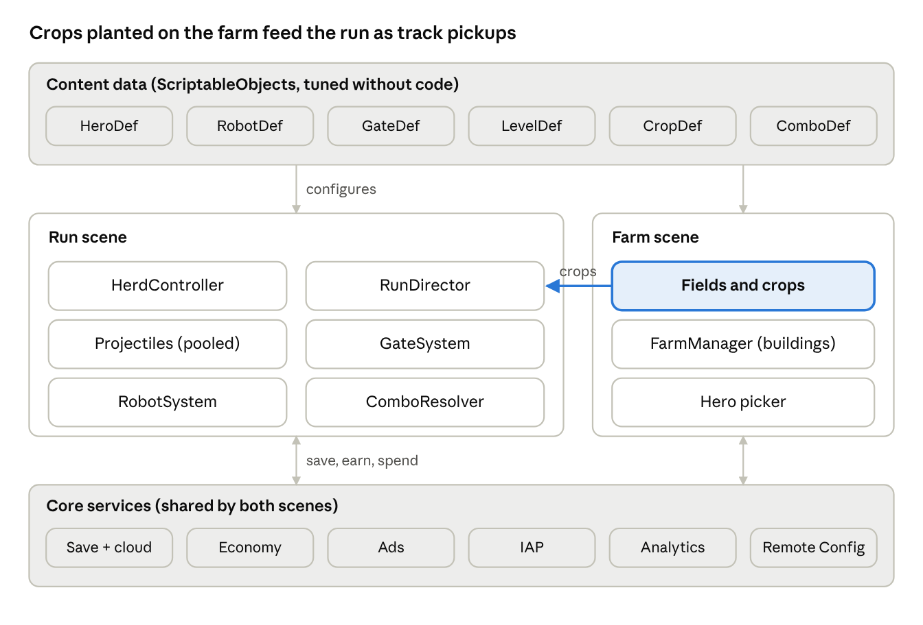
Unity architecture · data, two scenes, shared services
The Run and Farm scenes never call each other directly; they meet through the content data and the services layer. The one designed link is crops: the Fields system tells the RunDirector which pickups to place on the track.

Technology choices
Area | Choice | Notes
Engine | Unity 6 LTS, URP 2D renderer | Matches the FarmFury toolchain
Input | Input System package | Relative drag, keyboard for editor testing
Crowds and projectiles | Object pooling + Jobs/Burst for movement and hit tests | Target: 300 animals, 400 projectiles, 80 robots at 60 fps on a mid-range 2021 Android phone
Rendering | Sprite atlases, GPU instancing for the herd, one material per atlas | Keeps draw calls under 60
UI | uGUI for the HUD, UI Toolkit for menus
Save | Local JSON + Unity Cloud Save | Save on every results screen and building action
Ads | Unity LevelPlay (ironSource) mediation | Child-directed flag per player
IAP | Unity IAP | Server-side receipt check before v1.0
Analytics and tuning | Unity Analytics + Remote Config | Gate values, robot HP and ad frequency tunable live
Builds | Unity Build Automation or GitHub Actions with GameCI | Android first, then iOS; WebGL for playtests

Code rules
- One assembly definition per layer (Data, Run, Farm, Services, Tests) so Claude Code edits stay contained and compile fast.
- No singletons except a single Services locator; systems receive what they need through Init() calls.
- Every gameplay number comes from a ScriptableObject or Remote Config, never a literal in code.
- Edit-mode tests for maths (gate results, damage, economy) and play-mode tests for the hero balance check (section 4).
- Target sizes: under 150 MB install on Android, cold start under 5 seconds.

13. Building it with Claude Code
Claude Code writes the systems, tools and tests; the developer owns art, scene setup, game feel and playtesting. Each feature goes through the same short cycle, and every number Claude touches is checked by an automated test before it reaches a playtest.

Repository setup
- Own repo: create FarmFury_Rampage as its own Git repository (for example on the Desktop next to FarmFury_Arcade), not inside the shared home-folder repo.
- Unity .gitignore plus Git LFS for PNG, PSD, WAV and MP4 files.
- CLAUDE.md at the root covering: the layer and assembly layout (section 12), "no gameplay literals in code", how to run tests, naming rules, and the hero-balance rule (section 4).
- Optional Unity bridge: a Unity MCP editor bridge lets Claude Code read the Console, run tests and inspect scenes directly. Without one, Claude uses Unity's command line.

Feature cycle
- Plan: describe the feature in Claude Code's plan mode with the relevant GDD section pasted in; agree the classes and data first.
- Build: Claude writes the C# and ScriptableObject definitions and an edit-mode test.
- Test: Claude runs the tests in batch mode: Unity.exe -batchmode -projectPath . -runTests -testPlatform EditMode -testResults results.xml.
- Playtest: the developer wires the scene, plays it in the editor and reports what feels off.
- Tune: numbers change in ScriptableObjects or Remote Config, not code.
- Commit: one feature per commit, with a short message.

Guard rails learned from FarmFury
- Level data validation: FarmFury levels 2 to 6 broke on a coordinate bug. Rampage adds an edit-mode test that loads every LevelDef and fails if any gate, robot spawn or pickup sits outside the track bounds.
- Balance test: the four-hero time-to-clear check runs on every commit.
- Video clips: celebration clips are rendered with the background baked in; no chroma key.

Example prompts
Milestone | Prompt to Claude Code
Herd | "Build HerdController: relative drag input, phyllotaxis formation for up to 60 drawn animals, herd count with a 300 cap, pooled. Add edit-mode tests for formation bounds."
Gates | "Build GateSystem from GateDef: +, −, ×, ÷, buff, fury and guest gates; shoot-to-improve every 2 hits; red gates flip to blue at 0. Test every operation."
Heroes | "Create HeroDef assets for Cluck, Bessie, Horace and Ducky from GDD section 4, and a play-mode test proving each clears the reference waves within 5% of target."
Crops | "Build Fields in the Farm scene and the CropDef link so planted crops spawn as pickups in the next run (GDD section 6.1)."

Use the browser prototype first
The existing Cluck vs the Robots browser prototype is the place to tune the core loop (gate frequency, robot speed, herd growth) before any Unity work. Numbers that feel right there become the first ScriptableObject values.

14. Roadmap, risks and open questions
The plan reaches global launch in an estimated 30 weeks for a solo developer working with Claude Code. No phase starts until the gate before it passes, so the date moves rather than quality.
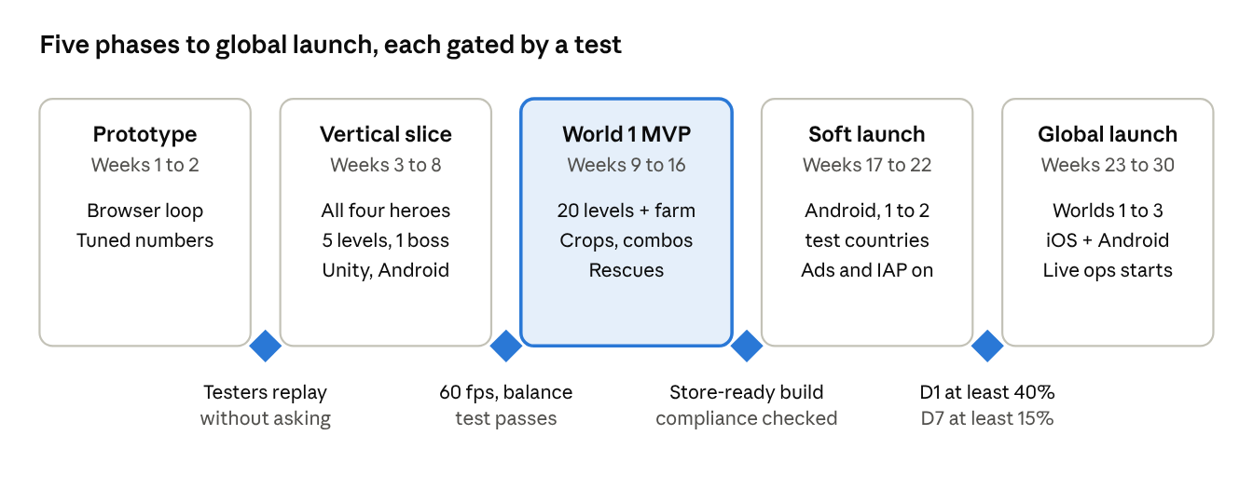
Roadmap · 5 phases, 4 gates, estimated 30 weeks
World 1 MVP is the big phase: it is where Plant your arsenal, Recipe combos and Rescues first come together. The retention targets are working benchmarks for a hybrid-casual game and should be checked against current market data before soft launch.

Risks
Risk | Impact | Mitigation
Crowded genre; looks like an ad clone | Low installs | Lead marketing with the unique hooks: crops on the track, combos, robot-turning
300-animal herd too slow on low-end phones | Bad reviews | Cap drawn animals at 60, performance gate before Phase 2
Equal-strength heroes feel samey | Hero choice stops mattering | Strong differences in feel, sound and Fury abilities; Recipe combos reward mixing
Child-audience ad and data rules | Store rejection, fines | Child-directed ads mode, compliance check at gate 3
Scope creep from the meta | Late launch | Farm limited to 8 buildings at launch; PvP and alliances out of scope
Level data bugs, as in FarmFury | Broken levels | Automated LevelDef validation test (section 13)

Open questions
- ☐ Should Rampage be a standalone app, or a mode inside FarmFury?
- ☐ Is Percy the pig the first rescue hero, or a launch hero alongside the four?
- ☐ 2D sprites or low-poly 3D for the crowd? This document assumes 2D.
- ☐ Which soft-launch countries?
- ☐ Is the real-weather link worth the location-permission prompt, or should farm weather stay in-game only?

